|  |  |
| --- | --- |
| Name: | Bodhisatya Ghosh |
| Class: | CSE DS |
| Batch: | B |
| UID: | 2021700026 |
| Experiment: | 1 |

**Aim:** Installation of Linux OS on Virtual Machine.

--------------------------------------------------------------------------------------------

**Installation**

**Step 1:** Create new virtual machine on VirtualBox

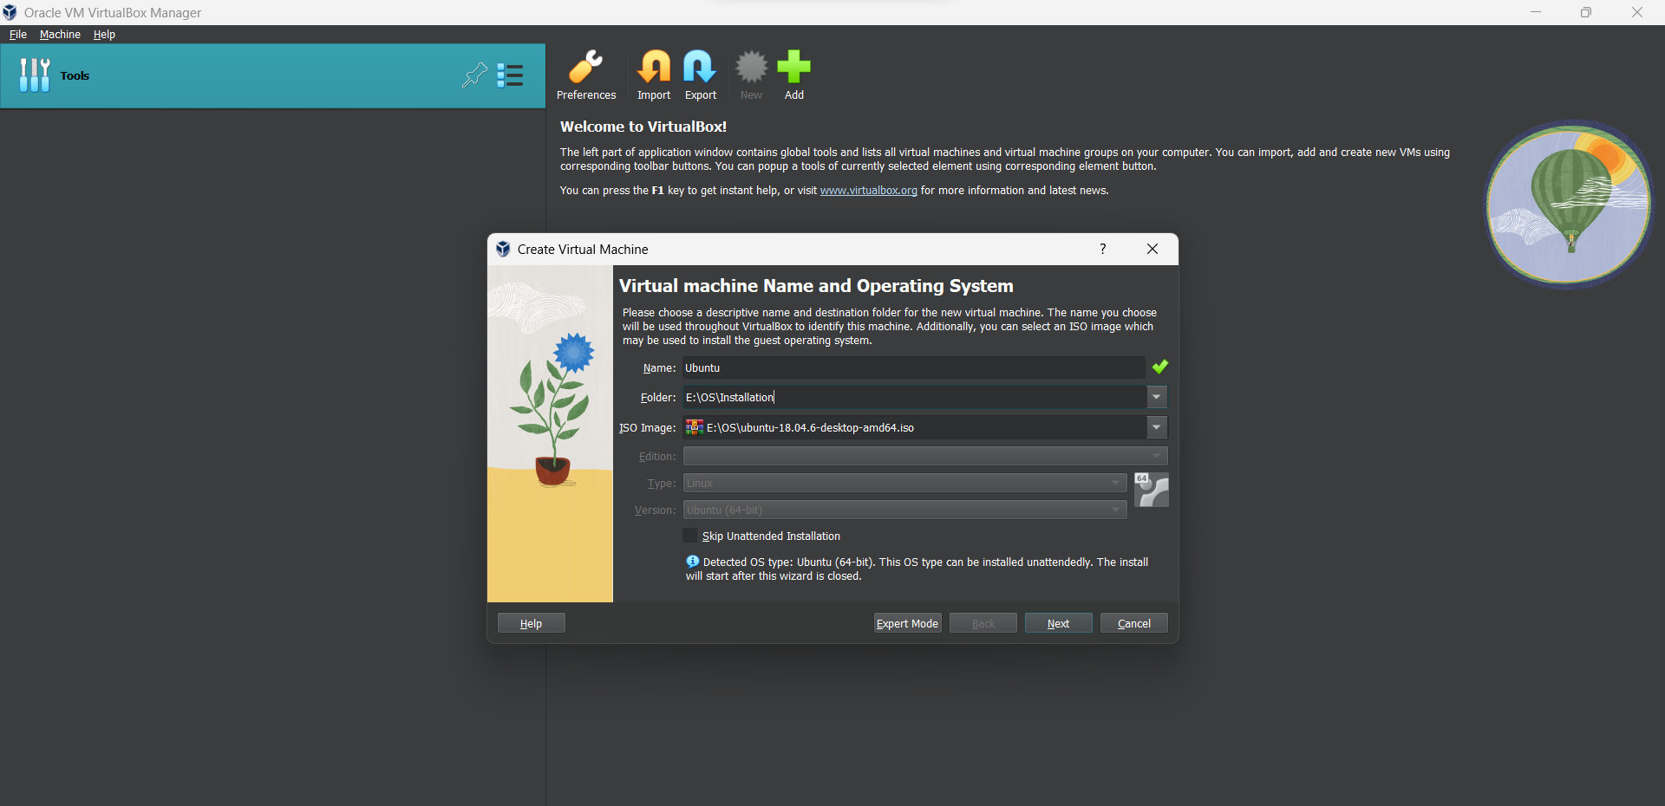

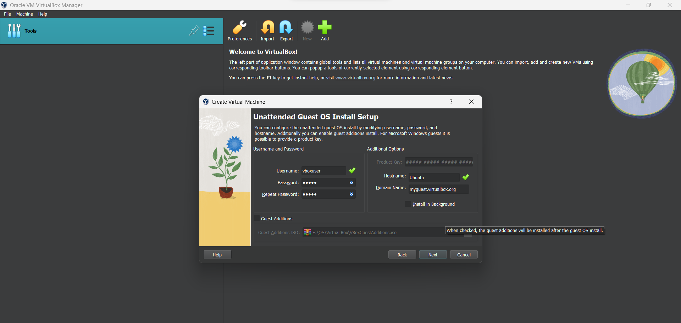

**Step 2:** A lot memory and CPUs to OS

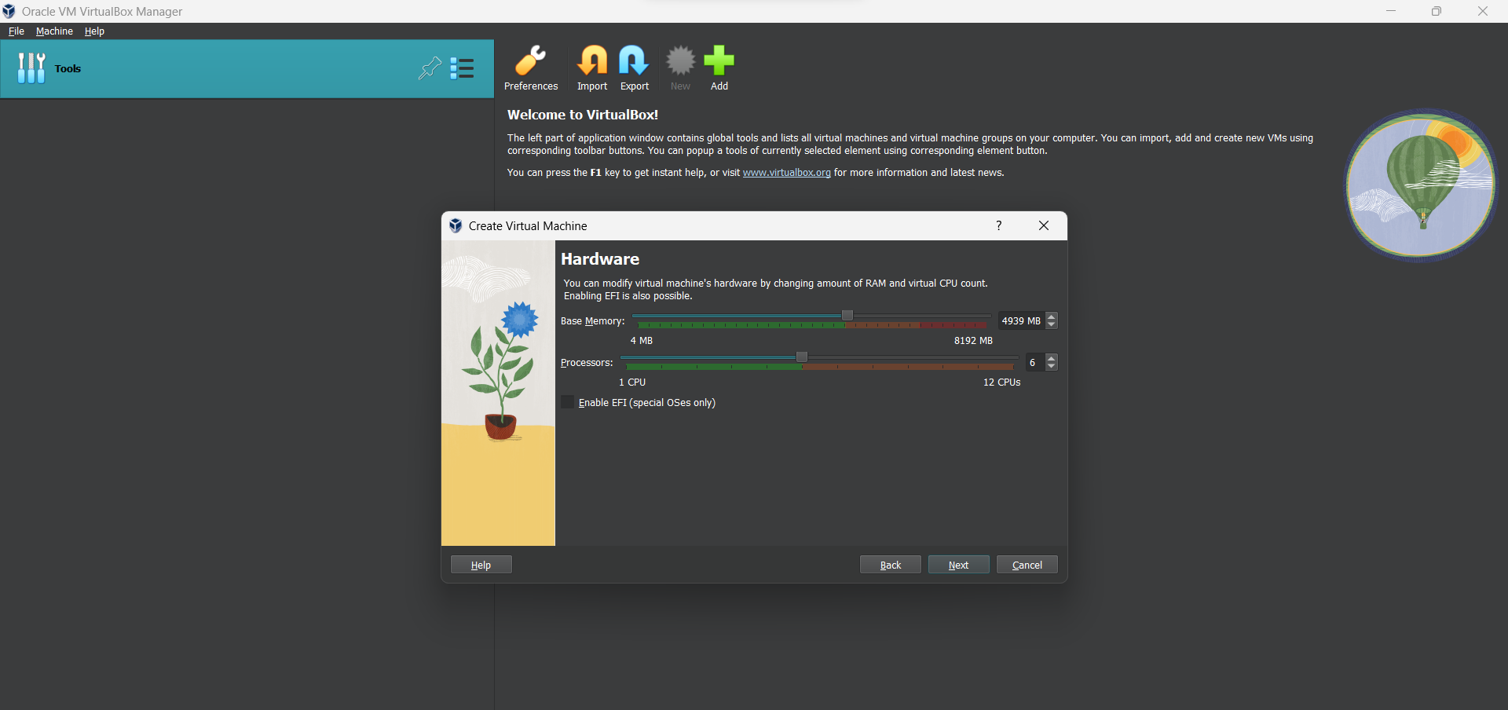

**Step 3:** Alot virtual storage to VM

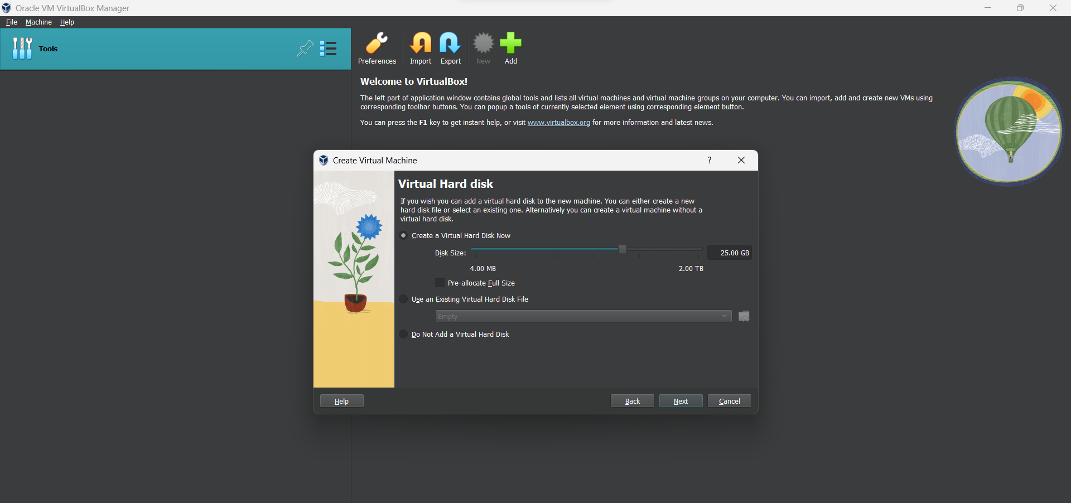

**Step 4:** Finish setup of Virtual machine on VirtualBox

**--------------------------------------------------------------------------------------------  
  
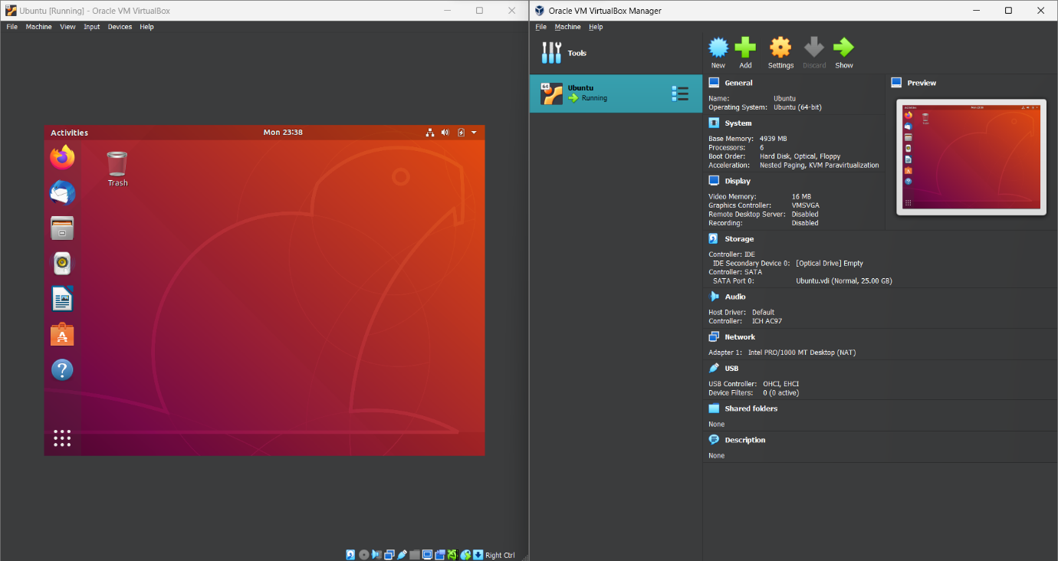Conclusion:** In this experiment OS installation has been demonstrated.